

STEM National Competition (NSTEMC)
SUMMARY OF PROJECT

last updated 10/08/21

This form is to be completed by the student and submitted along with the project.

Name & School:
Title of Project:

Objective (what I intended to accomplish):

Procedure (what steps I followed to prepare):

Conclusion (what I learned):

Project Requirement Checklist:

▪ Projects must follow the scientific method or engineering design process.

▪ Nothing on the project may identify the child, child’s gender, or school. This is including, but not limited to, photos, journals, labels, or titles. Journals are encouraged, providing they do not identify the student.

▪ If using a tri-fold board, the size of the project cannot be bigger than standard cardboard project boards (36” x 48”) available at many retail locations.

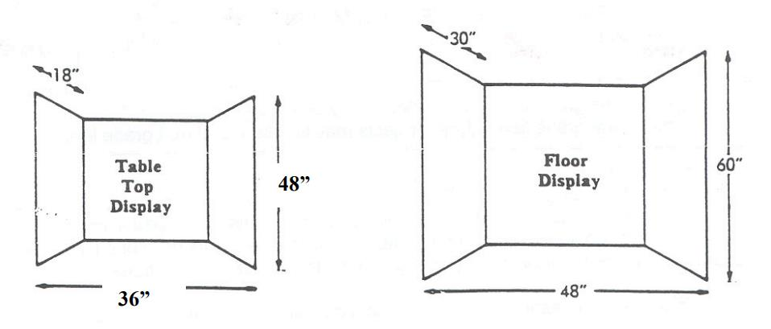

We will also be accepting boards created using presentation software, such as Microsoft PowerPoint or Google Slides. Note that these projects must be no more than 15 slides and must be saved as a PDF before submitting.

▪ Each project must include the completed Summary of Project form (the first page of this document) submitted with the project.

▪ The project must clearly reflect the students’ own efforts. If adult support is given, it should be acknowledged on the display.

Note: You can add as many pages you can if required to explain your project

